|  |  |  |
| --- | --- | --- |
|  | Table of contents |  |
| 1 admin_master |  | Page number: 2 |
| 2 category |  | Page number: 3 |
| 3 department |  | Page number: 4 |
| 4 migrations |  | Page number: 5 |
| 5 password_resets |  | Page number: 6 |
| 6 services |  | Page number: 7 |
| 7 subcategory |  | Page number: 8 |
| 8 subscription_plan |  | Page number: 9 |
| 9 user_certificate |  | Page number: 10 |
| 10 user_edu_data |  | Page number: 11 |
| 11 user_exp_data |  | Page number: 12 |
| 12 user_locations |  | Page number: 13 |
| 13 user_profile |  | Page number: 14 |
| 14 user_skill |  | Page number: 15 |
| 15 users |  | Page number: 16 |
| 16 users_logs |  | Page number: 17 |
| 17 Relational schema Page number: 18 | | |

1. **admin_master**

Table Comment : This table contains Admin user data

|  |  |  |  |  |  |  |  |  |
| --- | --- | --- | --- | --- | --- | --- | --- | --- |
| **Column** | **Type** | **Attributes** | **Null** | **Default** | **Extra** | **Links to** | **Comments** | **MIME** |
| id | int(10) | UNSIGNED | No |  | auto_increment |  | Id for admin |  |
| name | varchar(255  ) |  | No |  |  |  | Name of admin |  |
| email | varchar(255  ) |  | No |  |  |  | Email address of admin |  |
| password | varchar(255  ) |  | No |  |  |  | Password |  |
| type | varchar(255  ) |  | No |  |  |  | Type- Super Admin/ Normal Admin |  |
| remember_toke n | varchar(100  ) |  | Yes | NULL |  |  | Remember Token for authentication |  |
| created_at | timestamp |  | Yes | NULL |  |  | Data created date |  |
| updated_at | timestamp |  | Yes | NULL |  |  | Data updated date |  |
| secret | varchar(255  ) |  | No |  |  |  | Data deleted date (Soft delete) |  |

1. **Category**

Table Comment : This table contains category/skill data for employee or service provider

|  |  |  |  |  |  |  |  |  |
| --- | --- | --- | --- | --- | --- | --- | --- | --- |
| **Column** | **Type** | **Attributes** | **Null** | **Default** | **Extra** | **Links to** | **Comments** | **MIME** |
| cat_id | int(10) | UNSIGNED | No |  | auto_increment |  | Primary key |  |
| cat_name | varchar(255  ) |  | No |  |  |  | Category name |  |
| cat_department | varchar(500  ) |  | Yes | NULL |  |  | Employee department |  |
| is_subcategory | int(1) |  | Yes | 0 |  |  | Show sub category |  |
| cat_img | text |  | No |  |  |  | Category image |  |
| cat_type | int(1) |  | Yes | 1 |  |  | 1-employee,2-service |  |
| option_type | int(1) |  | Yes | 1 |  |  | 1-radio,2-checkbox |  |
| is_active | int(1) |  | Yes | 1 |  |  | 1-Active,0-inactive |  |
| created_by | int(11) |  | Yes | NULL |  |  | Created by admin id |  |
| created_at | timestamp |  | Yes | NULL |  |  | Created date |  |
| updated_at | timestamp |  | Yes | NULL |  |  | Modified date |  |
| deleted_at | timestamp |  | Yes | NULL |  |  | Soft deleted date |  |

1. **Department**

Table Comment : This table contains all data related to department (like Front office staff)

|  |  |  |  |  |  |  |  |  |
| --- | --- | --- | --- | --- | --- | --- | --- | --- |
| **Column** | **Type** | **Attributes** | **Null** | **Default** | **Extra** | **Links to** | **Comments** | **MIME** |
| dept_id | int(10) | UNSIGNED | No |  | auto_increment |  | Department Id |  |
| dept_name | varchar(500  ) |  | No |  |  |  | Department name |  |
| is_active | int(1) |  | Yes | 1 |  |  | 1-Active,0-inactive |  |
| created_at | datetime |  | Yes | NULL |  |  | Created date |  |
| created_by | int(10) |  | Yes | NULL |  |  | Created by admin id |  |
| updated_at | datetime |  | Yes | NULL |  |  | Modified date |  |
| deleted_at | datetime |  | Yes | NULL |  |  | Soft deleted date |  |

1. **Migrations**

Table Comment : This table contains migration detail through out the development

|  |  |  |  |  |  |  |  |  |
| --- | --- | --- | --- | --- | --- | --- | --- | --- |
| **Column** | **Type** | **Attributes** | **Null** | **Default** | **Extra** | **Links to** | **Comments** | **MIME** |
| migration | varchar(255  ) |  | No |  |  |  | Table names which migrate from laravel code |  |
| batch | int(11) |  | No |  |  |  | Batch number in which table created |  |

1. **password_resets**

Table Comment : This table contains reset password request detail from users

|  |  |  |  |  |  |  |  |  |
| --- | --- | --- | --- | --- | --- | --- | --- | --- |
| **Column** | **Type** | **Attributes** | **Null** | **Default** | **Extra** | **Links to** | **Comments** | **MIME** |
| email | varchar(255  ) |  | No |  |  |  | User email address |  |
| token | varchar(255  ) |  | No |  |  |  | Reset password token |  |
| created_at | timestamp |  | No | CURRENT_TI MESTAMP | on update CUR  RENT_TIMESTA MP |  | Password reset requested date |  |

1. **Services**

Table Comment : This table contains all services detail provided by service provider

|  |  |  |  |  |  |  |  |  |
| --- | --- | --- | --- | --- | --- | --- | --- | --- |
| **Column** | **Type** | **Attributes** | **Null** | **Default** | **Extra** | **Links to** | **Comments** | **MIME** |
| service_id | int(10) | UNSIGNED | No |  | auto_increment |  | Service Id |  |
| service_name | varchar(255  ) |  | No |  |  |  | Service Name |  |
| service_detail | text |  | No |  |  |  | Detail for Service |  |
| created_by | int(11) |  | Yes | NULL |  |  | User id of service provider |  |
| created_at | timestamp |  | Yes | NULL |  |  | Data created date |  |
| updated_at | timestamp |  | Yes | NULL |  |  | Data updated date |  |
| deleted_at | timestamp |  | Yes | NULL |  |  | Data deleted date |  |

1. **Subcategory**

Table Comment : This table contains Sub skill data which is basically depended on Skill/category table

|  |  |  |  |  |  |  |  |  |
| --- | --- | --- | --- | --- | --- | --- | --- | --- |
| **Column** | **Type** | **Attributes** | **Null** | **Default** | **Extra** | **Links to** | **Comments** | **MIME** |
| subcat_id | int(10) | UNSIGNED | No |  | auto_increment |  | Primary key of Sub category |  |
| cat_id | int(10) | UNSIGNED | Yes | NULL |  | category -> cat_id | Category id from category table |  |
| subcat_name | varchar(500  ) |  | Yes | NULL |  |  | Sub category name |  |
| created_at | datetime |  | Yes | NULL |  |  | Create timestamp |  |
| updated_at | datetime |  | Yes | NULL |  |  | Data updated date |  |
| deleted_at | datetime |  | Yes | NULL |  |  | Data deleted date (soft delete) |  |

1. **subscription_plan**

Table Comment : This table contains Subscription plan detail available for site

|  |  |  |  |  |  |  |  |  |
| --- | --- | --- | --- | --- | --- | --- | --- | --- |
| **Column** | **Type** | **Attributes** | **Null** | **Default** | **Extra** | **Links to** | **Comments** | **MIME** |
| plan_id | int(10) | UNSIGNED | No |  | auto_increment |  | Subscription plan id |  |
| plan_name | varchar(255  ) |  | No |  |  |  | Subscription plan name |  |
| plan_price | varchar(255  ) |  | No |  |  |  | Subscription plan price |  |
| plan_duration | int(10) | UNSIGNED | No |  |  |  | Plan duration |  |
| plan_detail | text |  | No |  |  |  | Plan detail |  |
| created_at | timestamp |  | Yes | NULL |  |  | Data created date |  |
| updated_at | timestamp |  | Yes | NULL |  |  | Data updated date |  |
| deleted_at | timestamp |  | Yes | NULL |  |  | Data deleted date (soft delete) |  |

1. **user_certificate**

Table Comment : This table contains educational/experience certificates data for user

|  |  |  |  |  |  |  |  |  |
| --- | --- | --- | --- | --- | --- | --- | --- | --- |
| **Column** | **Type** | **Attributes** | **Null** | **Default** | **Extra** | **Links to** | **Comments** | **MIME** |
| certi_id | int(10) | UNSIGNED | No |  | auto_increment |  | Certificate id |  |
| user_id | int(10) | UNSIGNED | Yes | NULL |  | users -> id | User id from user table |  |
| certi_url | text |  | No |  |  |  | Certificate upload Url |  |
| created_at | timestamp |  | Yes | NULL |  |  | Data created date |  |
| updated_at | timestamp |  | Yes | NULL |  |  | Data updated date |  |
| deleted_at | timestamp |  | Yes | NULL |  |  | Data deleted date (soft delete) |  |

1. **user_edu_data**

Table Comment : This table contains education data for user

|  |  |  |  |  |  |  |  |  |
| --- | --- | --- | --- | --- | --- | --- | --- | --- |
| **Column** | **Type** | **Attributes** | **Null** | **Default** | **Extra** | **Links to** | **Comments** | **MIME** |
| edu_id | int(10) | UNSIGNED | No |  | auto_increment |  | Education id |  |
| user_id | int(10) | UNSIGNED | No |  |  | users -> id | User id from user table |  |
| edu_degree | varchar(255  ) |  | Yes | NULL |  |  | Degree Name |  |
| edu_from_mont h | int(3) |  | No |  |  |  | Started in month of |  |
| edu_from_year | int(5) |  | No |  |  |  | Started in year |  |
| edu_to_month | int(3) |  | Yes | NULL |  |  | Ended in month of |  |
| edu_to_year | int(5) |  | Yes | NULL |  |  | Ended Year |  |
| edu_grade | varchar(255  ) |  | No |  |  |  | Achieved Grade |  |
| edu_institute | varchar(255  ) |  | No |  |  |  | Institute name |  |
| edu_detail | varchar(255  ) |  | No |  |  |  | Other educational detail |  |
| created_at | timestamp |  | Yes | NULL |  |  | Data created date |  |
| updated_at | timestamp |  | Yes | NULL |  |  | Data updated date |  |
| deleted_at | timestamp |  | Yes | NULL |  |  | Data deleted date (soft delete) |  |

1. **user_exp_data**

Table Comment : This table contains working experience data for user

|  |  |  |  |  |  |  |  |  |
| --- | --- | --- | --- | --- | --- | --- | --- | --- |
| **Column** | **Type** | **Attributes** | **Null** | **Default** | **Extra** | **Links to** | **Comments** | **MIME** |
| exp_id | int(10) | UNSIGNED | No |  | auto_increment |  | Experience id |  |
| user_id | int(10) | UNSIGNED | No |  |  | users -> id | User id from user table |  |
| exp_title | varchar(255  ) |  | No |  |  |  | Experience title |  |
| exp_company | varchar(255  ) |  | No |  |  |  | Company name |  |
| exp_loc | varchar(500  ) |  | Yes | NULL |  |  | Location of company |  |
| exp_from_month | int(3) |  | Yes | NULL |  |  | Started in month of |  |
| exp_from_year | int(5) |  | Yes | NULL |  |  | Stared in year |  |
| exp_to_month | int(3) |  | Yes | NULL |  |  | Ended in month of |  |
| exp_to_year | int(5) |  | Yes | NULL |  |  | Ended year |  |
| exp_detail | varchar(255  ) |  | No |  |  |  | Other detail |  |
| created_at | timestamp |  | Yes | NULL |  |  | Data created date |  |
| updated_at | timestamp |  | Yes | NULL |  |  | Data updated date |  |
| deleted_at | timestamp |  | Yes | NULL |  |  | Data deleted date (soft delete) |  |

1. **user_locations**

Table Comment : This table contains user location and other details

|  |  |  |  |  |  |  |  |  |
| --- | --- | --- | --- | --- | --- | --- | --- | --- |
| **Column** | **Type** | **Attributes** | **Null** | **Default** | **Extra** | **Links to** | **Comments** | **MIME** |
| loc_id | int(10) | UNSIGNED | No |  | auto_increment |  | Location id |  |
| user_id | int(10) | UNSIGNED | No |  |  | users -> id | User id from user table |  |
| loc_street | varchar(255  ) |  | No |  |  |  | Street address |  |
| loc_city | varchar(255  ) |  | No |  |  |  | City |  |
| loc_state | varchar(255  ) |  | No |  |  |  | State |  |
| loc_zip | int(10) | UNSIGNED | No |  |  |  | Zip code |  |
| user_contact | int(10) | UNSIGNED | No |  |  |  | Contact number |  |
| can_travel_upto | int(10) | UNSIGNED | No |  |  |  | Miles user can travel up to |  |
| created_at | timestamp |  | Yes | NULL |  |  | Data created date |  |
| updated_at | timestamp |  | Yes | NULL |  |  | Data updated date |  |
| deleted_at | timestamp |  | Yes | NULL |  |  | Data deleted date (soft delete) |  |

1. **user_profile**

Table Comment : This table contains basic detail of user

|  |  |  |  |  |  |  |  |  |
| --- | --- | --- | --- | --- | --- | --- | --- | --- |
| **Column** | **Type** | **Attributes** | **Null** | **Default** | **Extra** | **Links to** | **Comments** | **MIME** |
| upf_id | int(10) | UNSIGNED | No |  | auto_increment |  | User profile id |  |
| user_id | int(10) | UNSIGNED | No |  |  | users -> id | User id from user table |  |
| user_img | text |  | No |  |  |  | Image of user |  |
| user_position | varchar(255  ) |  | No |  |  |  | User designation |  |
| user_job_type | enum('1',  '2') |  | No | 1 |  |  | Job type - 1-permenant/2-temporary |  |
| user_bio | text |  | No |  |  |  | User description |  |
| avail_from_date | date |  | No |  |  |  | User available from date |  |
| avail_from_time | time |  | Yes | NULL |  |  | User available from time |  |
| avail_to_date | date |  | No |  |  |  | User available to date |  |
| avail_to_time | time |  | Yes | NULL |  |  | User available to time |  |
| company_name | varchar(255  ) |  | No |  |  |  | Company name (in case of employer) |  |
| user_services | varchar(255  ) |  | No |  |  |  | Available services (in case of service provider) |  |
| user_wage | varchar(255  ) |  | Yes | NULL |  |  | Hourly wage |  |
| user_salary | varchar(255  ) |  | No |  |  |  | Monthly Salary |  |
| created_at | timestamp |  | Yes | NULL |  |  | Data created date |  |
| updated_at | timestamp |  | Yes | NULL |  |  | Data updated date |  |
| deleted_at | timestamp |  | Yes | NULL |  |  | Data deleted date (soft delete) |  |

1. **user_skill**

Table Comment : This table contains user skill related data

|  |  |  |  |  |  |  |  |  |
| --- | --- | --- | --- | --- | --- | --- | --- | --- |
| **Column** | **Type** | **Attributes** | **Null** | **Default** | **Extra** | **Links to** | **Comments** | **MIME** |
| us_id | int(10) | UNSIGNED | No |  | auto_increment |  | User skill id |  |
| user_id | int(10) | UNSIGNED | No |  |  | users -> id | User id from user table |  |
| cat_id | int(10) | UNSIGNED | No |  |  | category -> cat_id | Skill/category id (from category table) |  |
| subcat_id | int(10) | UNSIGNED | No |  |  | subcategory -> subcat_id | Sub-skill id (from subcategory table) |  |
| exp_level | varchar(500  ) |  | Yes | NULL |  |  | Experience level - none/basic/high |  |
| created_at | timestamp |  | Yes | NULL |  |  | Data created date |  |
| updated_at | timestamp |  | Yes | NULL |  |  | Data updated date |  |
| deleted_at | timestamp |  | Yes | NULL |  |  | Data deleted date (soft delete) |  |

1. **Users**

Table Comment : This table contains important data of user

|  |  |  |  |  |  |  |  |  |
| --- | --- | --- | --- | --- | --- | --- | --- | --- |
| **Column** | **Type** | **Attributes** | **Null** | **Default** | **Extra** | **Links to** | **Comments** | **MIME** |
| id | int(10) | UNSIGNED | No |  | auto_increment |  | User Id |  |
| name | varchar(255  ) |  | No |  |  |  | User name |  |
| email | varchar(255  ) |  | No |  |  |  | User Email |  |
| password | varchar(255  ) |  | No |  |  |  | Password for user account |  |
| user_type | enum('1',  '2', '3') |  | No |  |  |  | Type - 1-employee/2-employer/3-service provider |  |
| social_media_id | varchar(255  ) |  | No |  |  |  | Social media id (in case of social media login) |  |
| social_media_ty pe | enum('1',  '2') |  | No |  |  |  | Type of social media - 1-facebook/2-linkedin |  |
| plan_id | int(10) | UNSIGNED | Yes | NULL |  |  | Subscription plan id |  |
| user_lat | varchar(255  ) |  | No |  |  |  | User latitude |  |
| user_lng | varchar(255  ) |  | No |  |  |  | User longitude |  |
| is_public | enum('1',  '2') |  | No | 1 |  |  | Make profile public or private - 1-public/2-private |  |
| remember_toke n | varchar(100  ) |  | Yes | NULL |  |  | Remember token for authentication |  |
| is_active | enum('1',  '2') |  | Yes | 1 |  |  | User is active or not - 1-active/2-inactive |  |
| created_at | timestamp |  | Yes | NULL |  |  | Data created date |  |
| updated_at | timestamp |  | Yes | NULL |  |  | Data updated date |  |
| deleted_at | timestamp |  | Yes | NULL |  |  | Data deleted date (soft delete) |  |

1. **users_logs**

Table Comment : This table contains all data regarding user action

|  |  |  |  |  |  |  |  |  |
| --- | --- | --- | --- | --- | --- | --- | --- | --- |
| **Column** | **Type** | **Attributes** | **Null** | **Default** | **Extra** | **Links to** | **Comments** | **MIME** |
| id | int(10) | UNSIGNED | No |  | auto_increment |  | Log id |  |
| user_id | int(11) | UNSIGNED | No |  |  | users -> id | User id from user table |  |
| action | varchar(255  ) |  | No |  |  |  | Action done by user |  |
| action_model | varchar(255  ) |  | Yes | NULL |  |  | Module used to do action |  |
| action_id | int(11) |  | Yes | NULL |  |  | Action id |  |
| created_at | timestamp |  | Yes | NULL |  |  | Data created date |  |
| updated_at | timestamp |  | Yes | NULL |  |  | Data updated date |  |

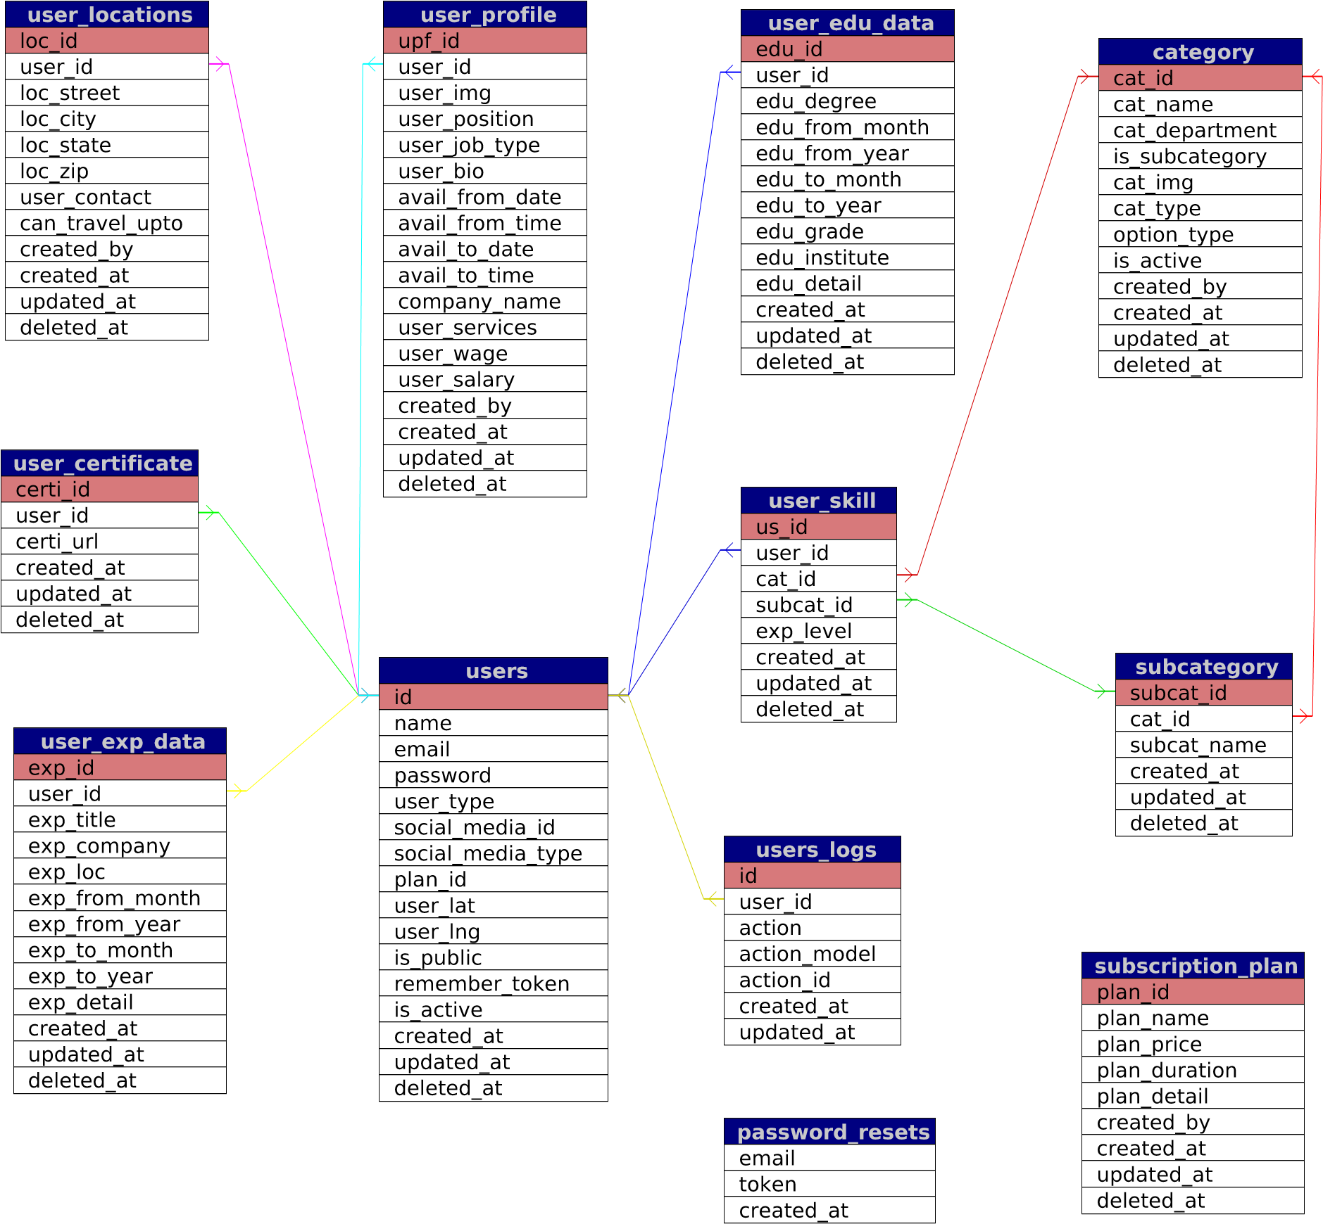

|  |
| --- |
| **admin_master** |
| id |
| name |
| email |
| password |
| type |
| remember_token |
| created_at |
| updated_at |
| secret |

|  |
| --- |
| **migrations** |
| migration |
| batch |

|  |
| --- |
| **department** |
| dept_id |
| dept_name |
| is_active |
| created_at |
| created_by |
| updated_at |
| deleted_at |

|  |
| --- |
| **services** |
| service_id |
| service_name |
| service_detail |
| created_by |
| created_at |
| updated_at |
| deleted_at |

[Powered by TCPDF (www.tcpdf.org)](http://www.tcpdf.org)